Shirt Recommendation Project Team Guide
  - Simple explanations for five members preparing a presentation and judge discussion
Our project lets a user describe a shirt in normal language. A hosted language model turns that request into SQL. DuckDB searches our prepared shirt catalog, and the website shows ranked matching products with images.
This guide explains what each member should understand, the work belonging to each role, and simple answers for a judge. Replace the member numbers with your names. Use the sample scripts for the work you actually handled; shared work can be explained together.

The project in one example
User request Plain black shirt under 1500 rupees.
Search conditions Color is only black, pattern is plain, and the catalog price is below INR 1,500. Shirts tagged navy|black or burgundy|black are excluded.
Output Matching shirts shown as cards containing product ID, title, image, price, rating and attribute status.

Five member responsibility map
Member | Main responsibility | What they hand to the next stage
1 | Dataset preparation | Clean shirt catalog with product IDs and image URLs
2 | Image attribute extraction | Colors patterns and uncertainty status per product
3 | Language model and SQL | A SQL filter based on the user request
4 | DuckDB and ranking | Matching products in a useful order
5 | Application and testing | A working search interface and tested demonstration

Numbers everyone should know
50,224 products share 31,793 unique image URLs. After the merge, 49,658 products have nonempty color tags and 41,752 have known patterns. These are coverage counts, not accuracy percentages. Some predictions remain uncertain or unknown.
Project folder C:\Users\thopa\OneDrive\Desktop\project\REAL SYSTEM\DuckDB idea

Project architecture
The top part prepares the data before searching. The lower part runs whenever a user submits a request. Product images are not reprocessed by the vision models for every search.
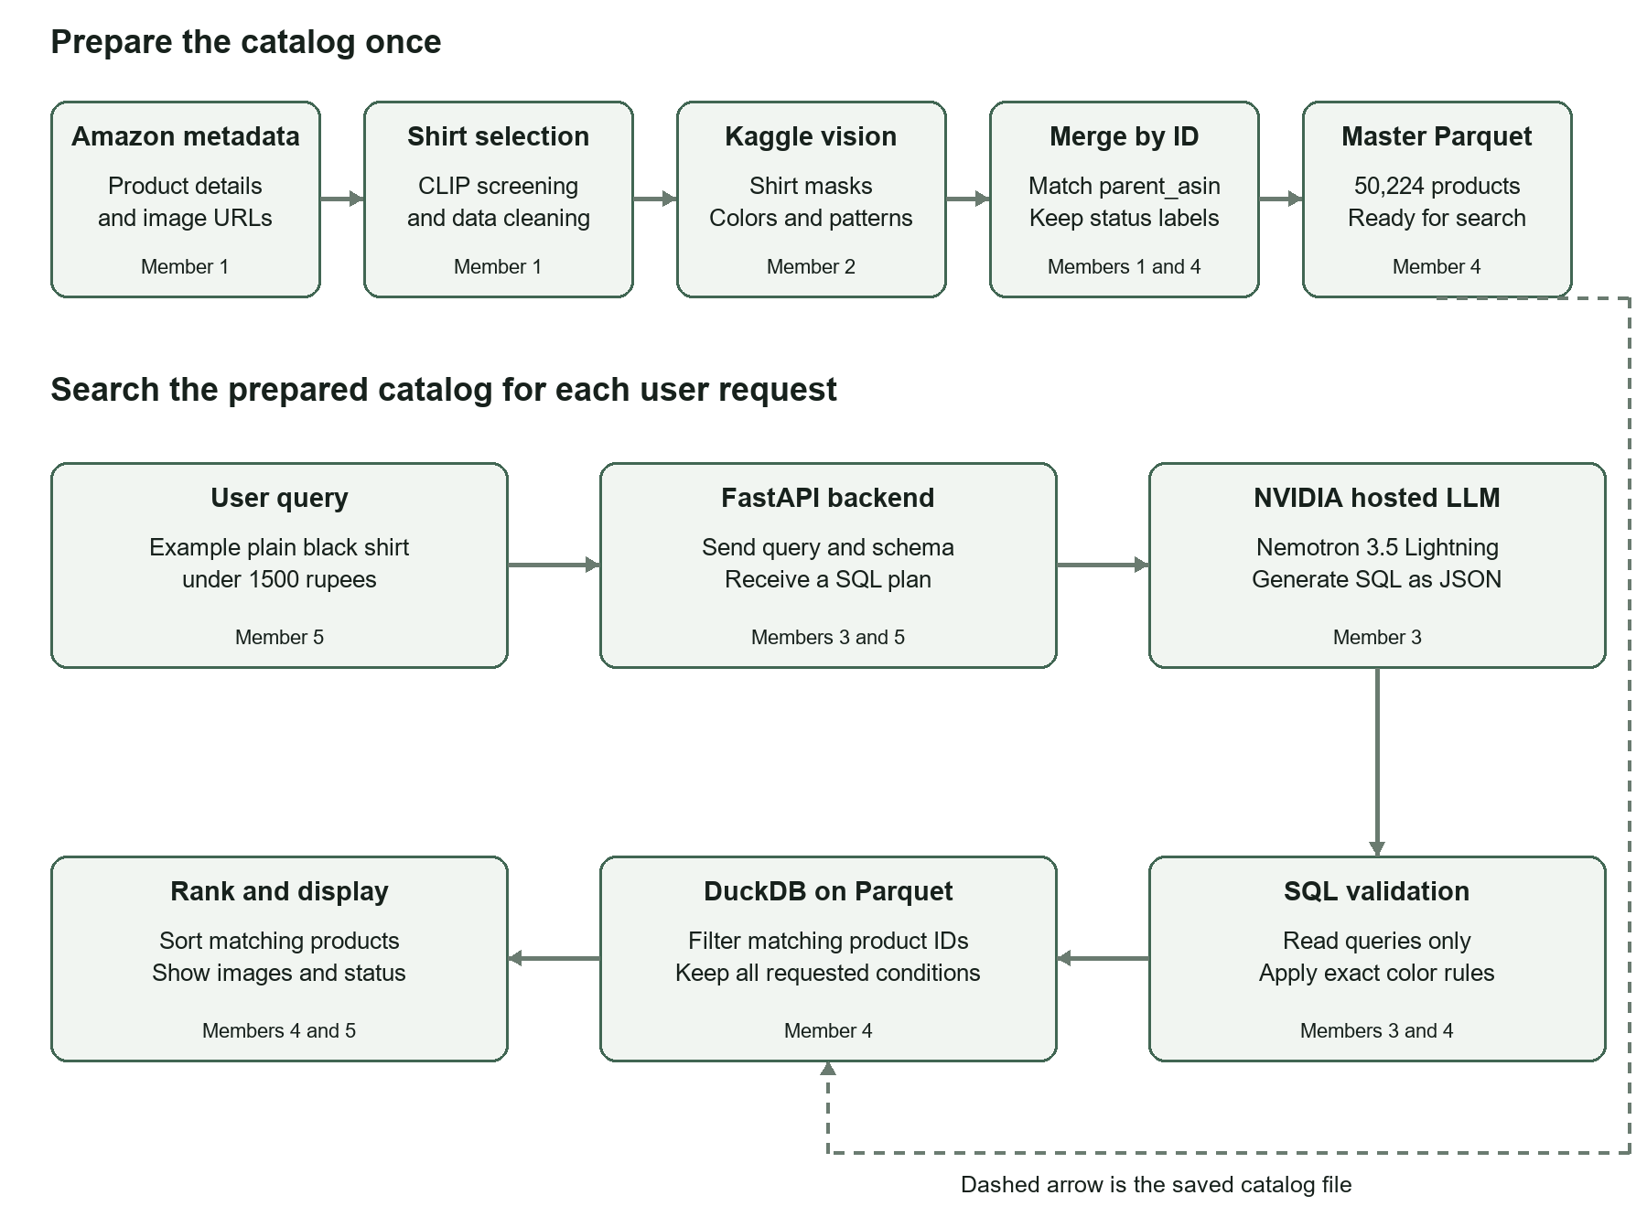

How to explain the diagram
- First we create a shirt catalog, run image models on Kaggle, and merge their results using parent_asin.
- During search, NVIDIA generates SQL. Our backend checks it before DuckDB reads the Parquet file.
- DuckDB finds products that meet the filters. The app ranks those products and shows their images and details.
Important distinction The vision models identify shirt attributes before search. The live NVIDIA language model interprets the request; it does not look at product images in this query flow.

Role 1 Dataset preparation
Assigned member ________________________________

Your job
Prepare a clean list of shirts so every later stage works on the same products.

Work you should understand
- Understand the Amazon 2023 product metadata: titles, brands, ratings and image links.
- Understand how the earlier CLIP screening selected shirts from the larger clothing catalog.
- Keep one record per parent_asin, check duplicate or missing IDs, and retain existing price, rating and review-derived fields.
- Prepare the master Parquet and its CSV copy. Keep IDs and image URLs consistent during the vision merge.

Words in simple language
Metadata Information about a product, such as its title, brand and image URL.
parent_asin The parent product identifier. We use it like a roll number to match records across files.
Parquet A compact table file that DuckDB can query. CSV is a plain table copy that is easy to inspect.

Short presentation script
My responsibility is dataset preparation. I work with the Amazon product metadata and the shirt-selection output. I check product IDs, organize useful fields and prepare the master catalog. The final catalog contains 50,224 products. Its stable product IDs let us attach image-based attributes without mixing up products.

Questions the judge may ask
Why do you need parent_asin? It connects a product to its color and pattern results. Row positions can change, but an ID match keeps the right attributes with the right product.
Did you collect live Amazon products? No. This is a research catalog derived from the Amazon 2023 dataset. The images are accessed through the saved URLs.
Files to show data/shirts_master.parquet, data/shirts_master.csv, merge_vision.py and data/vision_merge_summary.json.
Limitation to explain Product titles and old color tags are not always correct. A parent product can also have variants; the selected image does not describe every possible variant.

Role 2 Image based color and pattern extraction
Assigned member ________________________________

Your job
Use the product image to estimate the colors and pattern of the shirt fabric.

Work you should understand
- Run the v3.2 image pipeline on Kaggle using two T4 GPUs. This uses pretrained models for prediction, not new model training.
- Locate the shirt with Grounding DINO and get its mask with SAM. SegFormer supplies supporting clothing information.
- Name colors from retained shirt pixels using a color palette. Use CLIP plus a stripe-direction check for the pattern.
- Save predictions, product IDs, model signals and failure or uncertainty status. Process each identical image URL once.

Words in simple language
Mask A selection of image pixels believed to belong to the shirt. It is meant to exclude the background and other objects.
Inference Using a model that is already trained to make a prediction.
needs_review The script found uncertainty. It can still contain predictions, but it is not a verified label.

Short presentation script
My responsibility is image attribute extraction. I run the models on Kaggle to isolate shirts and estimate their colors and patterns. The script reuses results for shared images, so 31,793 unique images cover 50,224 products. We retain uncertainty labels and avoid inventing colors when the mask fails.

Questions the judge may ask
Why not use the whole image for color? It may contain pants, skin, a tie or a background. Those colors should not be treated as shirt fabric colors.
Are gold and yellow merged? No. The palette keeps them separate, just as it keeps maroon separate from red. The prediction can still be wrong because of lighting or masking.
Files to show Kaggle v3.2 vision_pipeline.py, attribute_core.py, shirt_attributes.py and the final shirt_results_backup ZIP.
Limitation to explain Masks can include accessories. Shadows can add extra shade names. The normal color list uses an 8 percent pixel-share threshold, so small printed colors may be omitted; raw candidates are retained.

Role 3 Language model and SQL generation
Assigned member ________________________________

Your job
Turn the user's ordinary sentence into a database search instruction.

Work you should understand
- Connect to NVIDIA's hosted Nemotron 3.5 Lightning model through its API.
- Send the request along with available columns, allowed attribute names and examples. The entire 50k catalog is not sent to the model.
- Ask the model for JSON containing SQL, an explanation, unsupported details and a sorting preference.
- Work with Member 4 to validate generated SQL and normalize color and pattern wording before execution.

Words in simple language
LLM A large language model. Here it interprets a sentence and writes SQL.
SQL A language for selecting records from a table using conditions.
API The connection through which our Python backend sends a request to NVIDIA and receives the model response.

Short presentation script
My responsibility is the natural-language query layer. I give the NVIDIA model the user request and our catalog schema. It generates a structured SQL plan. We check this plan and use the actual dataset vocabulary, so words such as striped map to the three stored stripe patterns. The model does not invent product records.

Questions the judge may ask
Does the model choose products from memory? No. It writes the filter. DuckDB selects actual records from our own Parquet catalog.
What happens with black shirts with white buttons? There is no button_color field. The app reports that detail as unsupported instead of claiming that it applied the condition.
Files to show llm_sql.py, app.py and tests/test_query_app.py. The private .env contains API settings and must not appear in slides.
Limitation to explain The model can generate incorrect SQL or misunderstand a request. SQL checks reduce execution and vocabulary errors, but they do not prove that every request is interpreted perfectly.

Role 4 DuckDB filtering and recommendation ranking
Assigned member ________________________________

Your job
Execute valid filters on the prepared data and put matching products in a useful order.

Work you should understand
- Merge vision results with the master using an exact parent_asin and image-URL match. Keep a backup of the original file.
- Create a DuckDB view of the Parquet catalog. Restrict queries to the shirt table and the configured data file.
- Apply color, pattern, sleeve and budget filters. For plain black, enforce only the black tag; mixed tags are excluded.
- Count all matches, rank them and return the requested number of product cards. Preserve historical or estimated price labels.

Words in simple language
DuckDB The SQL engine that reads and searches our table file. A separate database server is not needed.
Filtering Removing products that do not satisfy the requested conditions.
Ranking Sorting the remaining products. It does not bring back products that failed the filters.

Short presentation script
My responsibility is the data query and ranking layer. DuckDB reads the updated Parquet file and applies the validated conditions. For plain black under 1500, I require only black, plain pattern and the price limit. I rank only matching products. The current default favors historical exact-price records, then a rating score that accounts for rating count.

Questions the judge may ask
Why use DuckDB? It can run SQL directly on Parquet and is simple to use for this local catalog. We do not have to copy the data into a separate database server.
How are results ranked? The default uses price-source tiers and a rating average adjusted with a 20-review prior. Requests for cheapest, highest-rated or most reviewed use separate sorts.
Files to show query_engine.py, request_policy.py, merge_vision.py and data/shirts_master.parquet.
Limitation to explain Strict single-color filtering may exclude a truly black shirt if its prediction includes a shadow shade. Prices are historical or estimated, not live Amazon prices.

Role 5 Application integration and testing
Assigned member ________________________________

Your job
Give users a simple search page and check that the complete system works together.

Work you should understand
- Build the HTML, CSS and JavaScript search page and connect it to FastAPI routes.
- Show product images, titles, IDs, prices, ratings, color tags, patterns and uncertainty badges.
- Use Uvicorn to run the local app. Handle API errors, missing images, unsupported details and empty results clearly.
- Test merge alignment, SQL restrictions, exact colors, API behavior and real searches. Prepare a repeatable demonstration.

Words in simple language
Frontend The page the user sees and clicks.
Backend The Python code that receives the request, calls the model and searches the data.
Test A check with an expected outcome, such as proving that a plain black result has no other color tag.

Short presentation script
My responsibility is the interface and end-to-end integration. I connect the search form to the backend and show returned products as cards. I display estimated prices and uncertain attributes clearly. I test that valid requests work and unsafe SQL is rejected. The latest test run passed 18 automated checks, and live requests were also tested.

Questions the judge may ask
How do you test the whole flow? I send a real request through the API and check the returned records against the requested colors, pattern and budget. Automated tests also cover failures and invalid SQL.
What if there are no matches? The page shows no matching products. It does not silently remove a budget or color condition to fill the screen.
Files to show app.py, web/index.html, launch.py, Start_Query_App.bat and the tests folder.
Limitation to explain Passing software tests does not establish the visual accuracy of every color or pattern tag. Live stock, delivery and personalized recommendations are not implemented.

Demonstration and shared judge questions

A simple demonstration
- Start the app with Start_Query_App.bat and open http://127.0.0.1:8010.
- Search for plain black shirt under 1500. In the latest checked request, 20 products matched; all returned records were tagged only black, plain and below INR 1,500.
- Show a card and explain its image, product ID, price source and uncertainty status. Open the SQL details to explain which filters were used.
- Try blue and white striped shirts under 2000 rupees to show a multi-color request. One earlier live check found 10 matching records.
- Try black shirts with white buttons to demonstrate an unsupported field. Finish by explaining remaining limitations.

Answers all five members should know
Did you train all the models? The vision models and NVIDIA language model are pretrained. The earlier price-preparation stage trained a separate regression model on known prices. The search app uses its saved price estimates.
Are all 50k products tagged perfectly? No. Some tags are uncertain and some fields remain unknown. Coverage and successful processing are not accuracy measurements.
Is this the same system as the research paper? The paper is a reference for apparel recommendation. Our current implementation uses an LLM-to-SQL and DuckDB approach. It does not reproduce the paper's full cascaded review-embedding pipeline.
Is this Amazon or Flipkart's production architecture? No. It is our research prototype over an Amazon-derived catalog. We should not claim knowledge of their private production systems.
How do you prevent unwanted SQL operations? The backend permits a restricted read query, checks table and column names, blocks file readers and modifications, and restricts DuckDB's file access.
What is still missing? Live inventory, current prices, button color, exact size availability, personalization and a labeled evaluation of recommendation quality.
What does a price estimate mean? Many prices are estimated from the existing dataset-building stage. Cards label estimates, and INR values use the project's 83 INR per USD conversion.
How to rehearse Each member should explain their input, main steps, output and one limitation. Then practice handing the next stage to the next member. Understand the diagram rather than memorizing model names alone.

Technology stack for the live application
These technologies run the current query application. They are separate from the image models used earlier to prepare the catalog.
Technology | What it does | Where we use it
Python | Main programming language | Backend, merging, data checks and tests
NVIDIA hosted API | Runs the language model remotely | Interprets the request and produces the SQL plan
Nemotron 3.5 Lightning | The current text language model | Model ID nvidia/nemotron-3.5-lightning-30b-a3b; no local GPU is needed for the API call
SQL | Describes search conditions | Select matching product IDs using catalog fields
SQLGlot | Parses SQL into a structure we can check | Rejects unsupported operations and helps normalize attribute filters
DuckDB | Runs SQL on the Parquet file | Filters the catalog and supports deterministic ranking
Apache Parquet and PyArrow | Store and read the catalog efficiently | shirts_master.parquet and data exports
Pandas | Works with tables in Python | Merge attributes by ID, check data and prepare results
FastAPI and Pydantic | Provide backend routes and check request structure | Search, browsing and health endpoints
Uvicorn | Runs the local FastAPI server | Serves the app at port 8010
HTML CSS JavaScript | Build the page and handle interactions | Search form, loading states and product cards
Requests and JSON | Send API calls and exchange structured data | Python to NVIDIA and browser to backend
python dotenv | Loads private local settings | Provider URL, model and API key from .env
unittest and TestClient | Automated software checks | Merge, filter, SQL, API and integration tests

API access NVIDIA provides hosted access for prototyping, with account and model rate limits. A successful test does not establish unlimited free production access.
Credential handling The API key is stored in the local ignored .env file. Never put its value in a slide, screenshot, shared code file or document.

Technology stack for preparing the catalog
Technology or model | Simple purpose | Role in this project
Amazon 2023 metadata | Source product information | Starting data for the curated shirt catalog
CLIP ViT B 32 | Compares images with shirt descriptions | Earlier shirt-selection screening from the larger clothing dataset
Kaggle notebooks and T4 x2 | Provide cloud GPUs | Run the v3.2 vision script over the unique product images
Grounding DINO base | Finds the shirt location | Detects a shirt bounding box in a product image
SAM ViT base | Selects object pixels | Creates the main box-prompted shirt mask in v3.2
SegFormer B2 clothes | Recognizes clothing regions | Supporting overlap and clothing-region information; it is not the sole folded-shirt mask
CLIP ViT B 16 | Compares shirt images with pattern descriptions | Predicts the shirt pattern from the masked image
CIELAB and CIEDE2000 | Compare photographic colors | Name histogram colors using a 38-name shade palette
Image gradient analysis | Measures visible line direction | Supports horizontal vertical or diagonal stripe decisions
PyTorch and Transformers | Run pretrained image models | GPU inference and image-model processing
Hugging Face Hub | Provides model files and revisions | Downloads and records model snapshots
NumPy SciPy Pillow | Process pixels arrays and images | Masks, color statistics, stripe checks and previews
SQLite | Stores progress locally | Per-image checkpointing and resume without repeating completed URLs
CSV ZIP and JSON | Make outputs portable and inspectable | Results, backups, settings, vocabularies and summaries

Training versus prediction The Kaggle run used existing model weights. Our 50k catalog was processed for predictions; those models were not trained from scratch on it.
Earlier experiments Qwen2.5 VL and Keypoint R CNN were tried in the slower experimental pipeline. They are not active components of the final v3.2 catalog run or the current live search path.
Current boundaries The app uses existing review and rating fields, but it does not run a live sentiment model or the legacy cascaded review-embedding system for each request.

Technology stack for earlier dataset enrichment
The master catalog already contained price and text-derived fields before the final color and pattern merge. These earlier tools help explain where those fields came from. They are not rerun for every search.
Technology | Simple purpose | Existing use in the catalog
scikit learn | Tools for conventional machine learning | Preparing and training the earlier price-estimation pipeline
Gradient boosting | Learns how input details relate to a number | HistGradientBoostingRegressor estimates missing USD prices from product features
TF IDF | Turns words into numeric features | Represents product-title text for the earlier price model
Encoders and imputers | Prepare categories and missing values | Process brand and other features before prediction
Joblib | Saves and reloads a Python model | Stores the price-model bundle in data/price_model.joblib
Regular expressions | Find words and phrases in text | Extract fabric, fit and pocket clues; mine fit feedback from reviews
JSONL and gzip | Store large records in compressed files | Original Amazon metadata and review dataset formats

Explain price estimation simply
Some products have a price in the original metadata. For missing prices, the earlier estimator learns from products with known prices and predicts a value using features such as title and brand. An estimated value remains labeled estimated; it does not become an actual current Amazon price.

Explain review features simply
Earlier scripts search product text and review phrases for clues such as cotton, regular fit, runs small or true to size. These saved attributes are available in the catalog. This is different from running a new review-language model during every search.
Relevant files 03b_price_estimator_v2.py, 04_job_a_attributes.py, 06_job_c_review_mining.py and data/price_model.joblib.
Keep the distinction clear Kaggle vision predicts shirt colors and patterns. The NVIDIA language model writes SQL. The earlier regression model estimates missing prices. Each model has a different job.

